Demographic Biases in Naturalistic Language Recordings in the CHILDES Database
Camila Scaff^{1,2}, Georgia Loukatou³, Alejandrina Cristia¹, and Naomi Havron^{4,5, 6}
¹ Laboratoire de Sciences Cognitives et de Psycholinguistique,
Département d’études cognitives, ENS, EHESS, CNRS, PSL University
² University of Zurich
³ Stanford University
⁴ School of Psychological Sciences, University of Haifa
⁵ Center for the Study of Child Development, University of Haifa
⁶ Institute of Information Processing and Decision Making, University of Haifa

Abstract
In recent years, the importance of estimating demographic biases in research has become apparent. Here we provide a systematic review of the CHILDES database, the major source of naturalistic recordings of children’s linguistic environment. We analyzed the database according to four dimensions considered central to language learning: SES, urbanization, family structure, and language. We present descriptive statistics of each dimension to assess whether naturalistic recordings were biased regarding the demographics of the countries and the families recorded within them. We find that CHILDES’s recordings overrepresented wealthier countries and higher parental education levels; urban settings; and smaller households. Middle- and higher-class participants were likewise over-represented. The corpora were not representative of their countries in terms of urbanization either - with a larger percentage of families residing in urban settings than is overall true for their respective countries. In terms of family structure, nuclear families were more prevalent than in the countries where the data was collected. Last, we found that corpora were linguistically diverse, but we estimate that these recordings underrepresented bilingual and multilingual households. We conclude that researchers should be mindful when generalizing from naturalistic recordings of children's input and output obtained from CHILDES, and make recommendations for the future of the use of CHILDES.

Research highlights
● We examined CHILDES, the major source of data on children’s linguistic environment, for potential sampling bias in terms of SES, urbanization, family structure, and language.
● We found that the 48 countries represented in CHILDES overrepresented higher-GDP, educated, urbanized countries with small nuclear families.
● Within these countries, corpora overrepresented higher-SES, educated, urban, nuclear, and monolingual families.
● Interpretation of studies using CHILDES should acknowledge these biases.

Since its foundation in 1984, CHILDES (the Child Language Data Exchange System, MacWhinney, 2000) has been the major source of naturalistic recordings and transcript data for researchers studying language acquisition. Moreover, it has contributed to establishing seminal work in various domains such as Theory of Mind (Bartsch & Wellman, 1995) and memory (Anderson & Schooler, 1991). It has also inspired theories that help understand the connection between language input and development (Christiansen et al., 1998). As such, CHILDES has been and is one of the most valuable assets of our field. While much of previous work relied on one or a handful of corpora, even when all relevant corpora are used (Ibbotson & Browne, 2024, Tan et al. 2024), conclusions are more likely to be generalizable if they are based on representative data. We examine the extent to which CHILDES' naturalistic recordings, containing information about both input and output, come from a representative sample of the world's populations.
Researchers in many fields are increasingly aware of the bias their samples may have towards WEIRD populations (i.e., Western, Educated, Industrial, Rich, Democratic; Henrich 2010; Cychosz & Cristia, 2022; Nielsen et al., 2017; Moriguchi, 2021; Singh et al., 2023). Recent calls have been made to diversify research in psychology and developmental science to address this issue (Majid & Levinson, 2010; Kidd & Garcia, 2022; Blasi et al. 2022). For instance, Kidd and Garcia (2022) systematically reviewed publications from child-language journals. They revealed biases towards specific continents (North America and Europe) and languages (English, Spanish, French), highlighting the need for increased diversity in the populations and languages studied.
Every area of research conceptualizes different dimensions relevant to explaining variance for a given research topic. In what follows we present the four most relevant dimensions thought to play a role in language acquisition, particularly related to naturalistic recordings: socioeconomic status, urbanization, family structure, and language.

Socioeconomic Status
It is beyond the scope of this paper to detail all the theories that attempt to account for the complex causal pathways that may connect socio-economic status (SES) to children's language environments (see Rowe, 2018 for a discussion, and Golinkoff et al., 2019; Sperry et al., 2019 for diverse theoretical perspectives). While we do not take a stance on whether, how, or why SES and language environments relate to each other, SES is one of the factors that has been repeatedly studied in the context of early language acquisition, and as such, deserves attention. For example, Hoff (2003) compared the speech of high- versus middle-SES American mothers. College-educated mothers produced more utterances to their children, with more diverse vocabulary, longer phrases, and a higher number of utterances continuing a topic the child had brought up, which some claim to also be related to language outcomes (see also Hart & Risley, 1995; Hoff-Ginsberg 1990; Hoff, 2014; Huttenlocher, et al., 2002, 2007; see also Dailey & Bergelson, 2022; Piot et al., 2021; for meta-analyses supporting the link; and Bergelson et al., 2023 for a large-scale study finding no SES effects). In the developmental literature, SES is primarily indexed by parents’ education (Ensminger et al., 2003; Hoff, 2003), but can also be indexed by parental income, occupation, or a composite measure of these three (e.g. the Hollingshead index; Hollingshead, 1975).
Urbanization
This dimension represents differences across populations in terms of the extent to which they are organized around urban sites, which often entail differences in job opportunities, living conditions, and infrastructure. There have been proposals that societies varying in their urbanization have differing views and values about the role of children in conversations (e.g., Sharma & Levine, 1998; Richman et al., 1992; Draper & Harpending, 1987; Keller, 2012). For instance, Keller (2012) discusses three prototypical cases, urban, rural, and hybrid, which differ in terms of their goals for children: Urban families aim for child psychological independence, rural families for child physical autonomy and interdependence, and hybrid families for some mix. Vogt et al. (2020) found that the number of gestures, gesture-speech alignment, and gesture types all vary across the three groups in ways that can be related to Keller's typology, in urban Dutch, urban Mozambique, and rural Mozambique. Similarly, Cristia's (2023) systematic review uses urbanization to describe the frequency of child-directed vocalization, finding that it is far less frequent in rural than urban communities.
Family Structure
In this paper, we use the concept of family structure to encompass a variety of related aspects such as birth order and the way that caregiving is structured, each of which has an impact on child and language development (e.g., Blake, 1981; Duncan & Paradis, 2020; Havron et al., 2019, 2022, Hoff, 1993; Tomasello et al., 1995; Bornstein et al., 2019). For instance, children with older siblings exhibit lower language skills compared to first-born children across various cultures (e.g., Pyere et al., 2016 in France; Havron et al., 2022 in Singapore; Zambrana, et al., 2012 in Norway), although second-born children might benefit from overhearing conversations between their caregivers and older sibling (Oshima-Takane et al., 1996).
As for caregiving structures, in many middle-class Euro-American families, parents typically assume primary responsibility for children, with the mother as the primary caregiver (e.g., Bianchi & Milkie, 2010). However, certain cultures, like the Turkish families described by Isleyen (2021), adopt a different approach, with nuclear families living in separate apartments but sharing common spaces and caregiving responsibilities, resulting in extensive support networks.

Languages
Linguistic factors likely influence the development of language skills in children (Blasi et al, 2022; Kidd & Garcia, 2022). For example, based on transcriptions of conversations, Pye and colleagues documented that K’iche' Mayan children frequently use and understand passive constructions from a very young age, unlike their English-speaking peers, refuting the idea that passive constructions can only emerge later in development (Pye, 1980; Pye & Poz, 1988).
Similarly, many Indo-European languages show a strong noun bias in early vocabularies (a bias for acquiring words for concrete referential objects rather than actions), which has been claimed to be a universal feature of early language acquisition. However, studies have shown that in some Mayan languages, including Tseltal and Tsotsil (Casillas et al., 2024; De Leon, 1999), there is a verb bias instead. Thus, generalizations about language acquisition could be inaccurate when they rely on a linguistically biased database.
Another major dimension is the study of bilingualism or multilingualism (for an introductory review, see Höhle et al., 2019; and McCabe et al., 2013). There is evidence that monolingual and bilingual early language development differ in some aspects, particularly regarding phonological acquisition and word learning. For example, monolingual infants' ability to discriminate non-native sounds declines during the first year of age, whereas infants exposed to more language(s) maintain the discrimination window for a longer period (Singh et al., 2022). In terms of input, bilingual linguistic exposure is divided between two or more native languages. It has been shown that the amount of exposure to each native language can affect bilingual infants' speech discrimination abilities (Garcia-Sierra et al., 2011).

The current study
Inspired by calls to document the demographic and linguistic diversity of participant samples (Kidd & Garcia, 2021; Singh et al, 2023), we sought to provide a systematic analysis of the naturalistic speech corpora in the CHILDES database by quantifying the diversity of each dimension introduced above (SES, urbanization, family structure, and languages). Following Ghai's (2022) recommendation to enhance the description of diversity in behavioral sciences, we examined different levels, from a macro-level, involving broad country comparisons, to a corpus-level, where we analyzed individual corpora for a more detailed and nuanced understanding of the data.

Method

Inclusion criteria
We extracted information from the online CHILDES database in 2021, at which point there were 430 corpora. We excluded corpora on clinical populations (N = 69), in-lab recordings (N = 26), and elicitation tasks (N = 114), because they would have introduced additional sources of variation and biases. For example, the inclusion of clinical populations may highlight differences in access to diagnosis in different countries. Given our interest in naturalistic input and output represented in CHILDES, we also excluded corpora where only child speech was transcribed (N = 19) and diary studies (N = 11). Finally, we excluded 11 corpora that were not available, resulting in a final sample of 180 corpora containing naturalistic recordings of children's input and output.

Demographic Data Collection
Data on participant demographics was extracted from the references provided for each corpus in CHILDES such as articles, book chapters, dissertations, and the actual content of transcribed recordings (for more information please see SM1; Anonymized, 2024). When key variables could not be determined from these sources, we contacted corpus curators for missing information, and over a third (103 corpora, 32%) provided additional data or confirmed precoded information. They were also invited to correct our coding if it was inaccurate to their knowledge, and we took their coding as definitive. Unfortunately, curators for 50 corpora (15%) could not be contacted due to unresponsive email addresses (38 corpora), or the curator’s passing (12 corpora).

Analyses
Analyses and visualizations were carried out using R (version 4.1.2, R Core Team, 2020) and ggplot2 (Wickham, 2016). Data, scripts, and Supplementary Materials are available on the OSF (Scaff et al, 2024).

Results

Do Countries in Our CHILDES Sample Represent the World's Countries?
The 180 corpora included in this study represent 48 different countries or territories across all populated continents (see Figure 1). 28 countries, representing 151 corpora (84%), belong to the OECD (Organisation for Economic Co-operation and Development). Meanwhile, OECD countries represent only 19.5% of the world’s countries. The country with the most corpora is the United States with 30 different corpora, followed by Spain with 24, followed by the United Kingdom and France with 11. 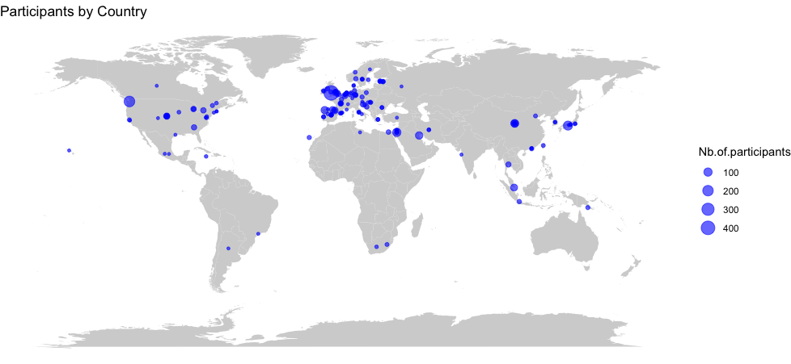
Figure 1. Geographical Distribution of the Corpora in CHILDES. Each circle represents a corpus, and its size is proportional to the number of participants.

Analysis of the number of utterances per country presents a different picture, with the United Kingdom having the largest number of utterances, followed by the United States, Japan, Indonesia and Spain (see Figure 2).
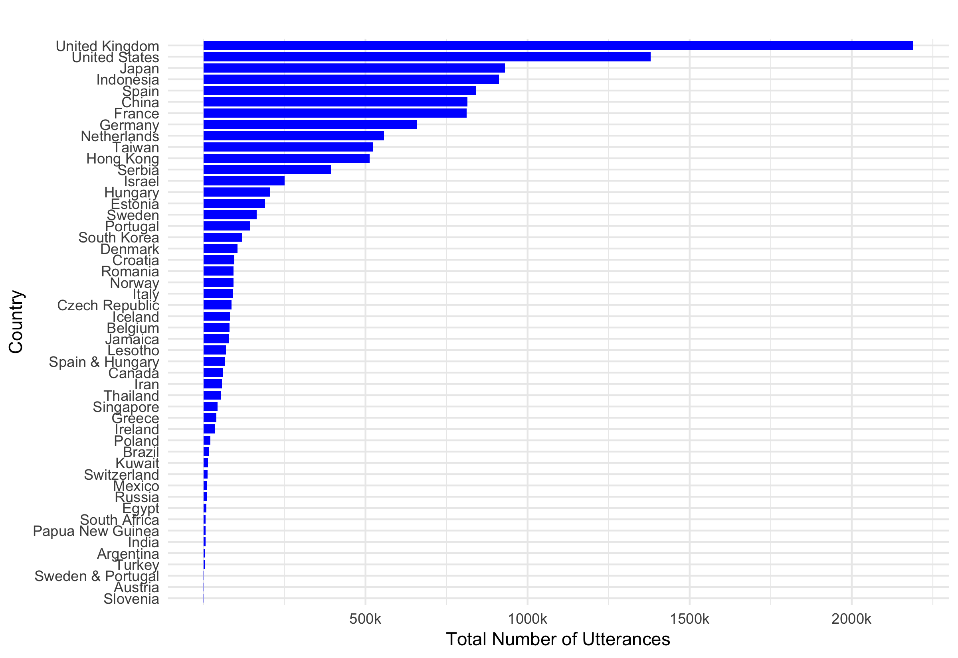

Figure 2. Number of utterances per country in CHILDES.
We first assessed the representativeness of our CHILDES sample by comparing country-level descriptors across - SES (education and GDP), urbanization, and family structure - against global distributions. We used public datasets from Our World in Data, the World Bank (World Development Indicators, WDI, Arel-Bundock, 2021), and the UN Household Size and Composition database (United Nations, 2022, see full details in SM1) to extract these global descriptors.
The countries in our sample of CHILDES differed significantly from the distribution of countries in the world on our key descriptors according to unpaired tests that did not assume equality of variances (Welch's t): a higher proportion of the population residing in our sample’s countries completed lower secondary school than the worldwide sample (% compl. LSS, t(130.41) = -6.19, p < .001); the countries were more urban (% urban, t(79.48) = -3.44, p < .001) and richer (log GDP per capita, t(102.35) = -6.02, p < .001); and they had smaller households (average household size, t(118.8) = 7.12, p < .001; see Figure 3).

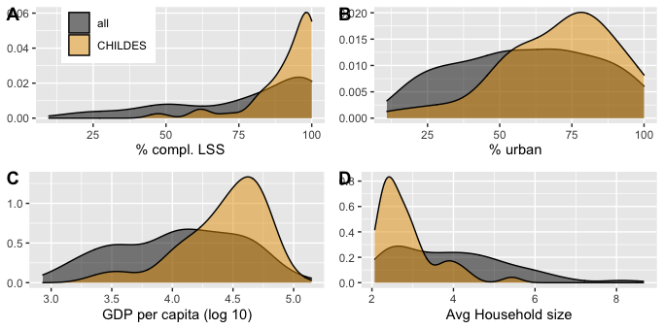
Figure 3. Comparison of Country-Level Descriptors Between World Countries and Our CHILDES Sample.

Note. Density plots show the distribution of country-level descriptors for all world countries (gray) versus countries represented in our sample of CHILDES (orange). % compl. LSS is the percentage of the country's population completing lower secondary school. % urban is the percent of the country's population residing in urban (as opposed to rural) locations. GDP stands for Gross Domestic Product. Avg Household size stands for average household size. To clarify, the calculations are based on unweighted country-level statistics (each country contributes equally to the distribution irrespective of population size). For example, panel A indicates that, worldwide, only a minority of countries have over 90% completion of lower secondary school, whereas in the CHILDES sample, the density curve shows a higher concentration of countries in this range.

How Representative and Diverse are Participant Samples?
We next investigated variables characterizing the specific families within each corpus, as far as possible given substantial missing data (see Table 1 and figures below for definitions of the variables and the number of corpora represented in each analysis, see SM1 for more details on variables).

Table 1. Variables of interest.
Dimension | Corpus level variable | Definition of levels | N corpus (% of corpora)
SES | Parent's socio-economic status | Low, mid, and/or high | 102 (57%)
SES | Parents’ education level | Highest level of education completed: Primary, High school, Undergraduate, Masters, PhD | 80 (44%)
SES | Parents’ occupation | Parents’ activity or profession | 84 (47%)
Urbanization | Type of community | Urban, rural, mixed | 65 (36%)
Family structure | Household composition | Whether the family was composed primarily of caregivers and children (nuclear) or also included other family members: grandparents, cousins, uncles, and/or aunts (extended) | 69 (38%)
Family structure | Percent children with sibling(s) | The percentage of children in the corpus who had at least one sibling | 93 (52%)
Family structure | Average number of siblings | How many siblings’ children had on average (including children with zero siblings) | 83 (46%)
Language | Language(s) spoken | Which languages were spoken in the transcripts and by the family | 180 (100%)
Language | Lingual status | Whether more than one language is spoken in the corpus (regardless of how many languages are spoken in the family or the community at large) | 110 (61%)

Socio-economic Status: SES, Education, and Occupation
The vast majority of families were of middle or higher SES. In about a fifth of the corpora samples were described as mixed (spanning lower to middle or higher SES). A very small percentage were described as families of low SES. As we show in SM2, this general distribution over-represents higher SES families.
A smaller proportion of corpora (additionally) reported parental education level (Figure 4). Among families in CHILDES, three-quarters included at least some children whose parents had a graduate or postgraduate degree. In fact, over half of the corpora contained data solely from children whose parents had at least a graduate degree. Overall, more educated parents were overrepresented when compared to their source countries, which is reinforced by the observations that parents had professions linked to graduate-level education in over half of corpora (see SM3).

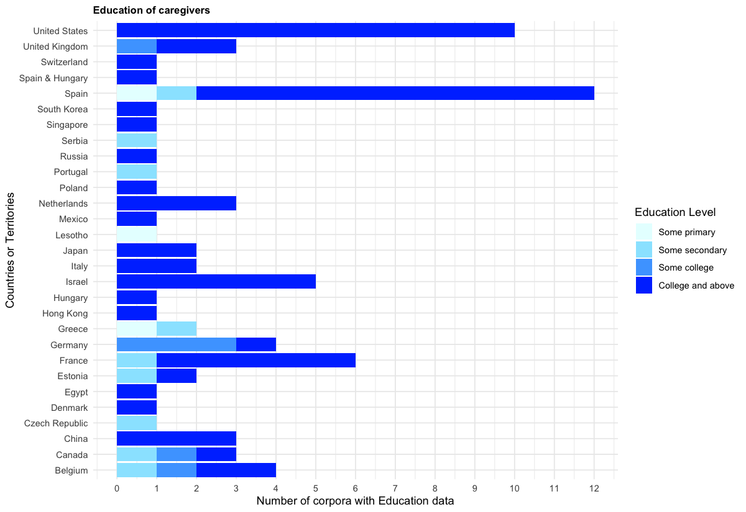
Figure 4. Distribution of Minimum Levels of Parental Education by Country. "Spain & Hungary" corresponds to a corpus collected in two countries. The order of countries is reversed-alphabetical. Note that the figure displays data only from countries for which we have available information. Note that corpora with missing data are not represented in the graph. The same applies for Figures 5-8.

Urbanization
The majority of corpora were urban (Figure 5), with an over-representation of urban households given the source countries (see SM4).

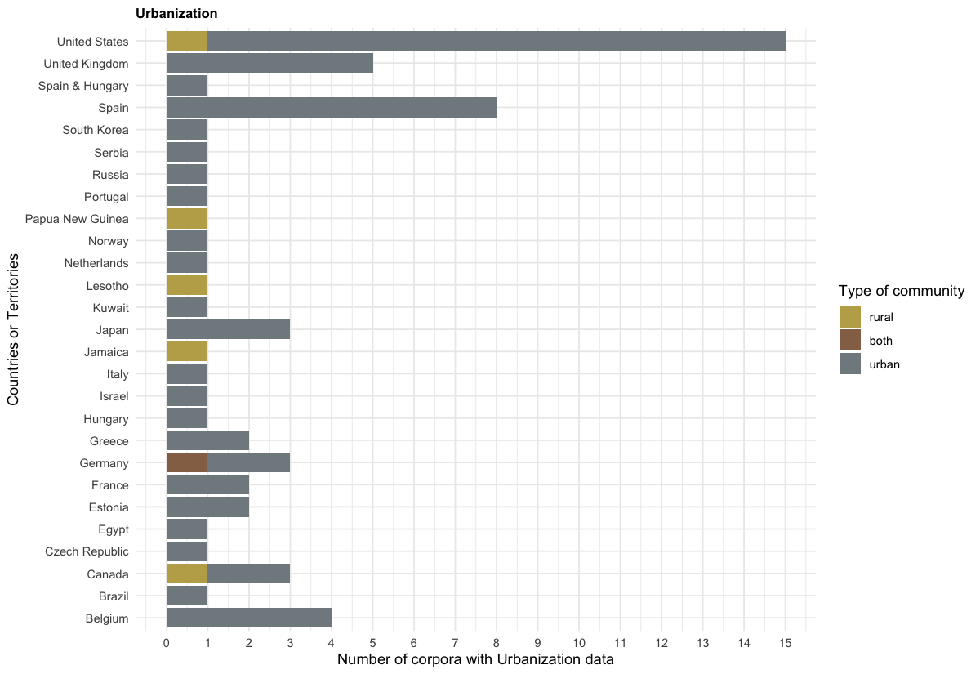
Figure 5. Distribution of Type of Community by Country.

Family Structure: Household composition and number of siblings
As Figure 6 shows, the overwhelming majority of corpora contained only nuclear families (i.e., parents and their children), and only a tiny percentage had a mixture of nuclear and extended families. We were not able to find a systematic database allowing us to check whether this was representative of the source countries.

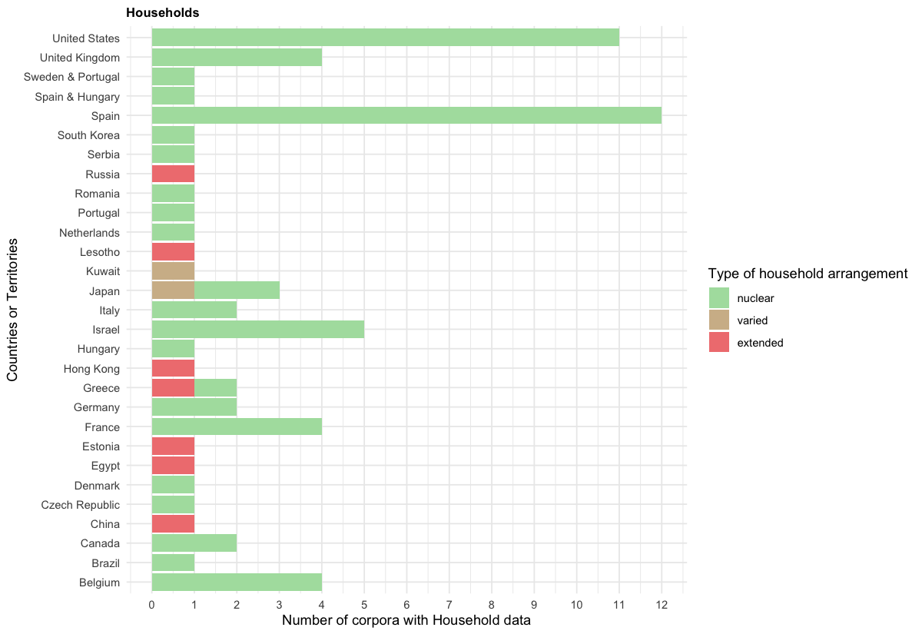

Figure 6. Distribution of Household Arrangement by Country. "Sweden & Portugal" corresponds to a corpus collected in two countries. The same applies for Figure 8.

Next, about a quarter of the corpora in our CHILDES sample consist exclusively of singletons (children with no siblings), while the remaining include children who have at least one sibling (Figure 7; see SM5 for why singletons might not be underrepresented).

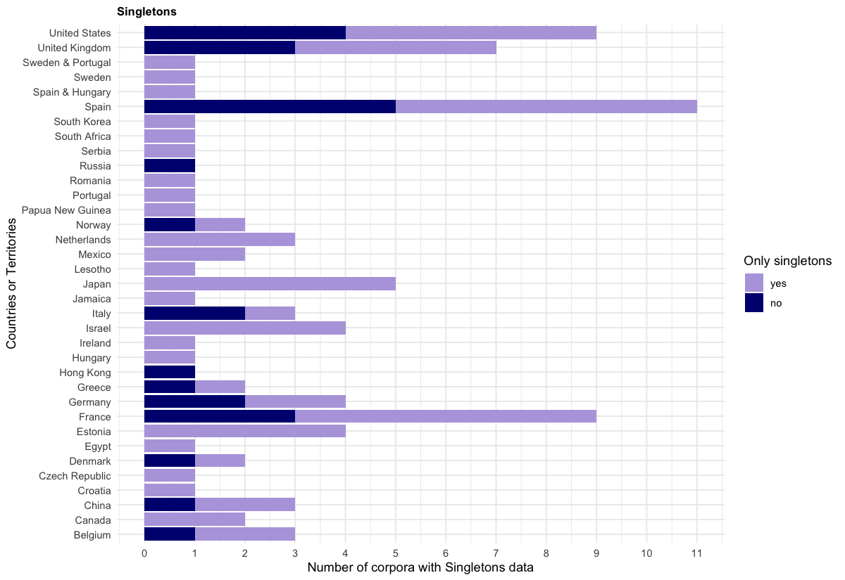

Figure 7. Distribution of Singletons by Country.

Languages
We found a total of 63 different languages or language combinations (for bilingual and multilingual children; see SM6). About a third of the included corpora were not monolingual. According to information in SM7, our sample of CHILDES underrepresents bilingual and multilingual households in the world.
As for linguistic diversity, most of the corpora pertain to Indo-European languages (Figure 8). English is the most prevalent language, with 50 corpora (30 exclusively monolingual), comprising 28% of the included corpora. Additionally, it is the language most studied for bilingualism or multilingualism, with English being combined with: Cantonese, Danish, Dutch, Farsi, French, Hebrew, Hungarian, Japanese, Mandarin, Portuguese, Russian, Spanish, and Swedish. The next most represented language in terms of different corpora is Spanish, with 25 corpora (14 monolingual).
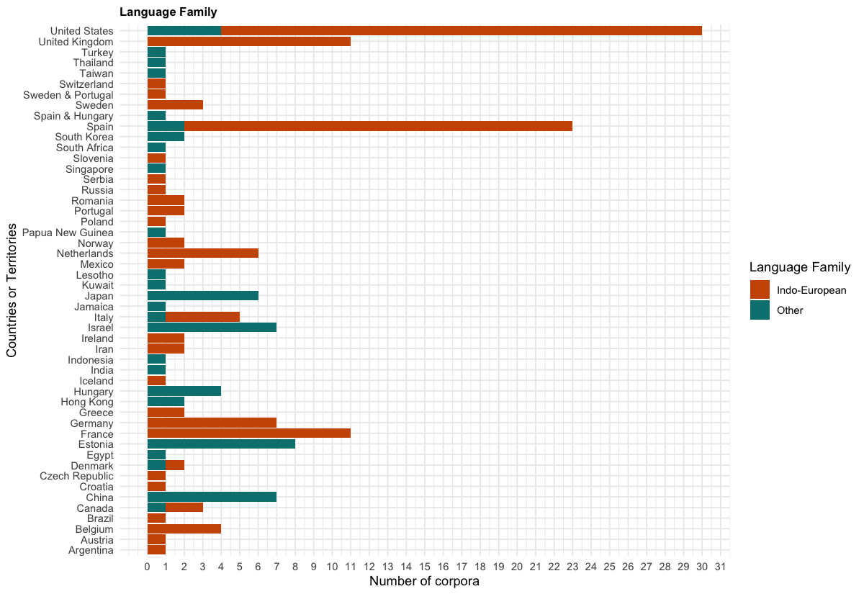
Figure 8. Distribution of Indo-European Languages by Country.

Discussion
The current paper provides a systematic review of corpora of naturalistic recordings in the CHILDES database, a priceless public research resource. We assessed and characterized sampling bias by examining the database through four dimensions believed to be relevant for early language acquisition: SES, urbanization, family structure, and languages.
Thanks to the collective work of nearly 300 individuals (with deep thanks to the people acknowledged in SM8), we included 180 corpora, in 63 different languages or language combinations, from 48 different countries, primarily OECD (84%). Despite a remarkable diversity in terms of languages and countries, analyses of the demographic characteristics of our CHILDES sample revealed several measures where the corpora do not represent the world population, nor faithfully represent the countries in which data were collected, in terms of SES, urbanization, family structure, and linguistic dimensions.
In terms of SES, our macro-level analyses showed that represented countries had a higher percentage of individuals completing lower secondary school, and higher Gross Domestic Product (GDP) per capita, compared to the worldwide distribution. Our analyses further suggested that higher SES families with highly educated parents were more common than would have been expected given their source countries. Considering the extensive literature linking SES and language acquisition, these are important biases to take into account.
Notably, approximately half of the corpora feature parents engaged in research-related professions, with academics frequently studying their own (grand-)children. In comparison, in the US general population, in 2020, only 6% of American citizens would fall under such definitions. The danger of extrapolating from such a sample goes beyond issues previously discussed in the context of convenience (homogeneous or heterogeneous) samples (Bornstein et al., 2013), with parents pursuing a career in academia (and likely in language-related areas) possibly being unusual in their linguistic behavior.
Regarding urbanization, 91% of corpora were urban, compared to 59% of the world population, with only 5 corpora exclusively rural. The latter seemed to be reasonable given urbanization statistics for the countries where data were collected. Thus, in this case, the bias pertains only to which countries are represented, and not how data are sampled within the country. One challenge for future work will involve teasing apart the ways in which urbanization may relate to language outcomes, including not only the parental goals mentioned in the Introduction (Keller, 2012) but also factors that may be confounded with urbanization. For example, a study using long-form recordings suggested that infants growing up in formerly rural families that had migrated to urban centers were afforded less spoken input, and had smaller vocabularies, than infants whose families had remained rural (Ma et al., 2024).
In terms of family structure, the represented countries had smaller households compared to the world average. When comparing household composition in our CHILDES sample with the countries where data had been collected, we found a possible trend for underrepresenting extended families. A bias towards nuclear families limits our understanding of diverse caregiving structures, particularly alloparental involvement, in language acquisition.
While multi-child families are well-represented in our CHILDES sample, the possible absence of other household members' speech in some transcripts (e.g., siblings' speech, Loukatou et al., 2022) could hinder insights into typical daily language interactions. Limited data on birth order also restricts robust conclusions on sibling configuration in CHILDES and underscores the need for broader exploration of non-parental caregiving roles typically overlooked in studies focusing on predominantly WEIRD households.
Finally, we found that English and more broadly Indo-European languages were overrepresented in our CHILDES sample, a point already made by others (e.g., Christiansen et al., 2022). This aligns with trends in child development literature (Kidd & Garcia, 2022; Singh et al., 2023). Interestingly, out of the 10 countries with the most utterances, 4 were countries or territories where non-Indo-European are the main languages spoken: Japan, Indonesia, China and Taiwan. Additionally, although a third of the corpora were not monolingual, this nonetheless underrepresents multilingualism in the world's population (Grosjean, 2024).
These biases likely have both proximal and distal consequences for child language. Proximally, studies on typologically diverse languages (e.g., Casillas et al., 2024; De León, 1999; Demuth, 2022; Pye, 1980) highlight the limitations of current acquisition theories to the extent they rely on biased samples. For example, theories like syntactic bootstrapping, which assume consistent exposure to specific sentence structures, were developed in the context of Indo-European language. These can struggle to generalize to free word order languages such as Warlpiri, and tend to stress the syntactic rather than morphological side of bootstrapping, as English is relatively morphologically impoverished language (Babineau et al., 2023).
Broader socioecological diversity, such as variations in SES that influence familial stress (Hart, 2024), or polyadic caregiving environments that shape input sources and conversational dynamics (Sagna et al., 2022), may open new ways of thinking about the forces driving some of our classical findings on SES and input. Multilingual settings add another layer of complexity; for instance, Thai-English bilinguals demonstrate distinct narrative styles and gestural patterns depending on the language used, reflecting cultural norms and linguistic features (Rochanavibhata & Marian, 2022).
More distal factors, such as noise pollution—more common in dense urban areas— linked with early brain development (Simon et al., 2022) can have downstream effects on language acquisition. Skewed samples not only hinder the testing and generalization of language acquisition theories, but also risk mischaracterizing developmental mechanisms more broadly.
Although our CHILDES sample is more homogeneous than expected given global and national variations, there remains substantial diversity across all the dimensions we studied. However, these dimensions are also confounded in these CHILDES corpora. Put simply, since most samples are from nuclear families with well-educated parents living in urban sites, it is impossible to tease apart these three dimensions. Additionally, this confound makes it hard to understand the intersectionality of such factors.
While making some strides in documenting the demographic characteristics of the people represented in naturalistic corpora in CHILDES, our work has several limitations. First, we focused on SES, urbanization, family structure, and language, but other dimensions may well be relevant for language acquisition research. We hope that our sharing of materials will facilitate others' addition of novel descriptors. Second, the absence of comprehensive data for certain variables restricted a thorough analysis of representativeness on some dimensions. This should not be seen as the fault of the corpus curators, as these data were not always available or were not considered relevant at the time. It is only recently that researchers started sounding the alarm regarding underreporting of relevant demographic characteristics (e.g., Singh, et al., 2023).
Our paper emphasizes the importance of evaluating the diversity of the samples we rely on. This issue is not unique to CHILDES, and applies broadly to any developmental archive (e.g., Databrary, Gilmore et al., 2016). In the era of big data, AI, and the rise of child-focused technologies, it is essential to consider the generalizations that models based on such data might produce for language acquisition - and reflect on how these models and generalizations impact the entire developmental field.
Researchers using CHILDES data should familiarize themselves with the demographic characteristics of their samples and acknowledge any limitations that could affect their findings. For future contributions, we recommend including demographic metadata following CHILDES’s already existing metadata system. Requiring data entry would ensure the inclusion of key descriptors at both the speaker and corpus levels, improving the database’s demographic information. When collecting data, purposive sampling can help include all key sub-groups for a representative sample (see Bornstein et al., 2013). Collaborating with local communities and adopting participatory practices (Gehlert & Mozersky, 2018) can enhance data collection in diverse contexts.
Finally, systemic changes in academia are crucial for fostering long-term diversity. Journals, editorial boards, and funding agencies should create opportunities and provide support for studies on underrepresented populations and researchers. Adopting key performance indicators for diversity—focusing on linguistic, geographic, and socioeconomic representation (Havron et al., 2022)—and increasing the inclusion of non-Western authors in developmental science (Aravena-Bravo, et al., 2024) are actionable steps to address systemic biases.
To conclude, we found that many countries and languages are represented in CHILDES, but that these countries did not constitute a representative sample of the world's countries, and that for many dimensions, families were not representative of their own countries. We also noted low variability along certain dimensions (e.g., SES and family structure) and the predominance of Indo-European languages, with English having the most recorded corpora. Despite these limitations, CHILDES remains an unparalleled resource that has contributed significantly to the field over decades, exemplifying the success of open and collaborative science. Our discussion leads us to argue for the systematic inclusion of descriptors in speaker-level and corpus-level CHILDES metadata, to track and quantify both diversity and representativity.

Acknowledgements
We are grateful to Lara Oliel and Clara Daoud for help entering corpus-level data; Sara Pisani for organizing communication with corpus curators; Brian MacWhinney for support and encouragement when retrieving information from corpus curators. We particularly want to thank the literally hundreds of researchers who contributed data to CHILDES, without which this project would be unthinkable; and the 103 curators who replied to our request.
AC acknowledges financial and institutional support from Agence Nationale de la Recherche (ANR-16-DATA-0004 ACLEW, ANR-17-EURE-0017, ANR-14-CE30-0003 MechELex); the J. S. McDonnell Foundation Understanding Human Cognition Scholar Award; and the European Research Council (ERC) under the European Union’s Horizon 2020 research and innovation programme (ExELang, Grant agreement No. 101001095). GL acknowledges financial support from Fondation Fyssen.

References
Anderson, J. R., & Schooler, L. J. (1991). Reflections of the environment in memory.
Psychological Science, 2(6), 396-408. https://doi.org/10.1111/j.1467-9280.1991.tb00174.x
Aravena-Bravo, P., Cristia, A., Garcia, R., Kotera, H., Nicolas, R. K., Laranjo, R., ... & Woon, F.
T. (2024). Towards Diversifying Early Language Development Research: The First Truly Global International Summer/Winter School on Language Acquisition (/L+/) 2021. Journal of Cognition and Development, 25(2), 242-260. https://doi.org/10.1080/15248372.2023.2231083
Babineau, M., Havron, N., Dautriche, I., de Carvalho, A., & Christophe, A. (2023). Learning to
predict and predicting to learn: Before and beyond the syntactic bootstrapper. Language Acquisition, 30(3-4), 337-360. https://doi.org/10.1080/10489223.2022.2078211
Bartsch, K., & Wellman, H. M. (1995). Children talk about the mind. New York, NY: Oxford
University Press. https://doi.org/10.1093/oso/9780195080056.001.0001
Bergelson, E., Soderstrom, M., Schwarz, I.-C., Rowland, C. F., Ramirez-Esparza, N., Hamrick,
L. R., et al. (2023). Everyday language input and production in 1,001 children from six continents. Proceedings of the National Academy of Sciences, 120(52), e2300671120.https://doi.org/10.1073/pnas.2300671120
Bianchi, S. M., & Milkie, M. A. (2010). Work and family research in the first decade of the 21st
century. Journal of Marriage and Family, 72(3), 705-725. https://doi.org/10.1111/j.1741-3737.2010.00726.x
Blake, J. (1981). Family size and the quality of children. Demography, 18(4), 421-442.
https://doi.org/10.2307/2060941
Blasi, D. E., Henrich, J., Adamou, E., Kemmerer, D., & Majid, A. (2022). Over-reliance on
English hinders cognitive science. Trends in Cognitive Sciences, 26(12), 1153-1170.
https://doi.org/10.1016/j.tics.2022.09.015
Bornstein, M. H., Jager, J., & Putnick, D. L. (2013). Sampling in developmental science:
Situations, shortcomings, solutions, and standards. Developmental Review, 33(4), 357-370. https://doi.org/10.1016/j.dr.2013.08.003
Bornstein, M. H., Putnick, D. L., & Suwalsky, J. T. (2019). Mother-infant interactions with
firstborns and secondborns: A within-family study of European Americans. Infant Behavior and Development, 55, 100-111. https://doi.org/10.1016/j.infbeh.2019.03.009
Casillas, M., Foushee, R., Méndez Girón, J., Polian, G., & Brown, P. (2024). Little evidence for
a noun bias in Tseltal spontaneous speech. First Language, 44(6) 600-628.
https://doi.org/10.1177/01427237231216571
Christiansen, M. H., Allen, J., & Seidenberg, M. S. (1998). Learning to segment speech using
multiple cues: A connectionist model. Language and Cognitive Processes, 13(2-3), 221-268. https://doi.org/10.1080/016909698386528
Christiansen, M. H., Contreras Kallens, P., & Trecca, F. (2022). Toward a comparative approach
to language acquisition. Current Directions in Psychological Science, 31(2), 131-138.
https://doi.org/10.1177/09637214211049229
Cristia, A. (2023). A systematic review suggests marked differences in the prevalence of
infant-directed vocalization across groups of populations. Developmental Science, 26(1), e13265. https://doi.org/10.1111/desc.13265
Cychosz, M., & Cristia, A. (2022). Using big data from long-form recordings to study
development and optimize societal impact. In R. Kail (Ed.), Advances in Child Development and Behavior (Vol. 62, pp. 1-36). Academic Press. https://doi.org/10.1016/bs.acdb.2021.12.001
Dailey, S., & Bergelson, E. (2022). Language input to infants of different socioeconomic
statuses: A quantitative meta-analysis. Developmental Science, 25(3), e13192.
https://doi.org/10.1111/desc.13192
De León, L. (1999). Verbs in Tzotzil (Mayan) early syntactic development. International
Journal of Bilingualism, 3(2-3), 219-239. https://doi.org/10.1177/13670069990030020601

Demuth, K. (2022). The acquisition of Sesotho. In D. I. Slobin (Ed.), The crosslinguistic study of
language acquisition (pp. 557-638). Psychology Press. https://doi.org/10.4324/9781315808208-11
Draper, P., & Harpending, H. (2017). Parent investment and the child's environment. In J. B.
Lancaster, A. Rossi, & J. Altmann (Eds.), Parenting across the life span (pp. 207-236). Routledge. https://doi.org/10.4324/9781315126005-11
Duncan, T. S., & Paradis, J. (2020). Home language environment and children's second language
acquisition: The special status of input from older siblings. Journal of Child Language, 47(5), 982-1005. https://doi.org/10.1017/S0305000919000977
Ensminger, M. E., & Fothergill, K. E. (2014). A decade of measuring SES: What it tells us and
where to go from here. In M. H. Bornstein & R. H. Bradley (Eds.), Socioeconomic status, parenting, and child development (pp. 13-27). Routledge.
Garcia-Sierra, A., Rivera-Gaxiola, M., Percaccio, C. R., Conboy, B. T., Romo, H., Klarman, L.,
… Kuhl, P. K. (2011). Bilingual language learning: An ERP study relating early brain responses to speech, language input, and later word production. Journal of Phonetics, 39(4), 546-557. https://doi.org/10.1016/j.wocn.2011.07.002
Gehlert, S., & Mozersky, J. (2018). Seeing beyond the margins: Challenges to informed
inclusion of vulnerable populations in research. Journal of Law, Medicine & Ethics, 46(1), 30-43. https://doi.org/10.1177/1073110518766006
Ghai, S. (2021). It's time to reimagine sample diversity and retire the WEIRD dichotomy.
Nature Human Behaviour, 5(8), 971-972. https://doi.org/10.1038/s41562-021-01175-9
Gilmore, R. O., Adolph, K. E., & Millman, D. S. (2016, August). Curating identifiable data for
sharing: The databrary project. In 2016 New York Scientific Data Summit (NYSDS) (pp. 1-6). IEEE. https://doi.org/10.1109/NYSDS.2016.7747817
Golinkoff, R. M., Hoff, E., Rowe, M. L., Tamis-LeMonda, C. S., & Hirsh-Pasek, K. (2019).
Language matters: Denying the existence of the 30-million-word gap has serious consequences. Child Development, 90(3), 985-992. https://doi.org/10.1111/cdev.13128
Grosjean, F. (2024). The statistics of bilingualism. In J. F. Kroll & A. M. B. de Groot (Eds.), On
bilinguals and bilingualism (pp. 138-147). Cambridge University Press.
https://doi.org/10.1017/9781009210409.010
Hart, B., & Risley, T. R. (1995). Meaningful differences in the everyday experience of young
American children. Baltimore, MD: Paul H Brookes Publishing.
Hart, E., Troller-Renfree, S. V., Sperber, J. F., & Noble, K. G. (2024). Relations among socioeconomic
status, perceived stress, and the home language environment. Journal of child language, 51(5), 1067-1084. https://doi.org/10.1017/S0305000923000156

Havron, N., Lovcevic, I., Kee, M. Z., Chen, H., Chong, Y. S., Daniel, M., … Tsuji, S. (2022).
The effect of older sibling, postnatal maternal stress, and household factors on language development in two-to four-year-old children. Developmental Psychology, 58(11), 2096. https://doi.org/10.1037/dev0001417
Havron, N., Ramus, F., Heude, B., Forhan, A., Cristia, A., Peyre, H., & EDEN Mother-Child
Cohort Study Group. (2019). The effect of older siblings on language development as a function of age difference and sex. Psychological Science, 30(9), 1333-1343. https://doi.org/10.1177/0956797619861436
Havron, N., Scaff, C., Hitczenko, K., & Cristia, A. (2022). Community-set goals are needed to increase diversity in language acquisition research: A commentary on kidd and garcia (2022). First Language, 42(6), 765–769. https://doi.org/https://doi.org/10.1177/01427237221096087
Henrich, J., Heine, S. J., & Norenzayan, A. (2010). Most people are not WEIRD. Nature,
466(7302), 29. https://doi.org/10.1038/466029a
Hoff, E. (2003). The specificity of environmental influence: Socioeconomic status affects early
vocabulary development via maternal speech. Child Development, 74(5), 1368-1378.
https://doi.org/10.1111/1467-8624.00612
Hoff, E. (2014). Causes and consequences of SES-related differences in parent-to-child speech.
In M. H. Bornstein & R. H. Bradley (Eds.), Socioeconomic status, parenting, and child development (pp. 147-160). Routledge.
Hoff-Ginsberg, E. (1990). Maternal speech and the child's development of syntax: A further
look. Journal of Child Language, 17(1), 85-99. https://doi.org/10.1017/S0305000900013118
Hoff-Ginsberg, E., & Krueger, W. M. (1991). Older siblings as conversational partners.
Merrill-Palmer Quarterly, 37(3), 465-482.
Höhle, B., Bijeljac-Babic, R., & Nazzi, T. (2020). Variability and stability in early language
acquisition: Comparing monolingual and bilingual infants' speech perception and word recognition. Bilingualism: Language and Cognition, 23(1), 56-71.
https://doi.org/10.1017/S1366728919000348

Hollingshead, A. B. (1975). Four-factor index of social status. New Haven, CT: Yale University.

Huttenlocher, J., Vasilyeva, M., Cymerman, E., & Levine, S. (2002). Language input and child
syntax. Cognitive psychology, 45(3), 337-374. https://doi.org/10.1016/S0010-0285(02)00500-5
Huttenlocher, J., Vasilyeva, M., Waterfall, H. R., Vevea, J. L., & Hedges, L. V. (2007). The
varieties of speech to young children. Developmental Psychology, 43(5), 1062.
https://doi.org/10.1037/0012-1649.43.5.1062
Ibbotson, P, & Browne, W. J. (2024). The effects of family, culture and sex on
linguistic development across 20 languages. Developmental Science 27(6), e13547. https://doi.org/10.1111/desc.13547
Isleyen, M. A. (2021). Marital functioning and parenting in extended family living arrangements:
A qualitative study in family buildings [Master's thesis, Istanbul Bilgi University].
Keller, H. (2012). Autonomy and relatedness revisited: Cultural manifestations of universal
human needs. Child Development Perspectives, 6(1), 12-18.
https://doi.org/10.1111/j.1750-8606.2011.00208.x
Kidd, E., & Garcia, R. (2022). How diverse is child language acquisition research? First
Language, 42(6), 703-735. https://doi.org/10.1177/01427237211066405

Loukatou, G., Scaff, C., Demuth, K., Cristia, A., & Havron, N. (2022). Child-directed and
overheard input from different speakers in two distinct cultures. Journal of Child Language, 49(6), 1173--1192. https://doi.org/10.1017/S0305000921000623
Ma, Y., Zhang, X., Pappas, L., Rule, A., Gao, Y., Dill, S. E., ... & Rozelle, S. (2024).
Associations between urbanization and the home language environment: Evidence from a LENA study in rural and peri‐urban China. Child Development, 95(2), e74-e92. https://doi.org/10.1111/cdev.14034
MacWhinney, B. (2000). The CHILDES project: Tools for analyzing talk. MIT Press.

Majid, A., & Levinson, S. C. (2010). Weird languages have misled us, too. Behavioral and Brain
Sciences, 33(2-3), 103-103. https://doi.org/10.1017/S0140525X1000018X
McCabe, A., Tamis-LeMonda, C. S., Bornstein, M. H., Brockmeyer Cates, C., Golinkoff, R.,
Wishard Guerra, A., et al. (2013). Multilingual children beyond myths and toward best practices. Social policy report, 4(27). Society for Research in Child Development. https://doi.org/10.1002/j.2379-3988.2013.tb00077.x
Moriguchi, Y. (2022). Beyond bias to Western participants, authors, and editors in
developmental science. Infant and Child Development, 31(1), e2256.
https://doi.org/10.1002/icd.2256
Nielsen, M., Haun, D., Kärtner, J., & Legare, C. H. (2017). The persistent sampling bias in
developmental psychology: A call to action. Journal of Experimental Child Psychology, 162, 31-38. https://doi.org/10.1016/j.jecp.2017.04.017
Oshima-Takane, Y., Goodz, E., & Derevensky, J. L. (1996). Birth order effects on early
language development: Do secondborn children learn from overheard speech? Child Development, 67(2), 621-634. https://doi.org/10.1111/j.1467-8624.1996.tb01755.x
Peyre, H., Bernard, J. Y., Hoertel, N., Forhan, A., Charles, M.-A., De Agostini, M., et al.
(2016). Differential effects of factors influencing cognitive development at the age of 5-to-6 years. Cognitive Development, 40, 152-162. https://doi.org/10.1016/j.cogdev.2016.10.001
Piot, L., Havron, N., & Cristia, A. (2022). Socioeconomic status correlates with measures of
Language Environment Analysis (LENA) system: A meta-analysis. Journal of child language, 49(5), 1037-1051. https://doi.org/10.1017/S0305000921000441
Pye, C. L. (1980). The acquisition of grammatical morphemes in Quiche Mayan [Doctoral
dissertation, University of Pittsburgh].
Pye, C., & Poz, P. Q. (1988). Precocious passives (and antipassives) in Quiche Mayan. Journal
of Child Language, 15(1), 129-135.
R Core Team. (2020). R: A language and environment for statistical computing. R Foundation
for Statistical Computing, Vienna, Austria. URL https://www.R-project.org/.
Richman, A. L., Miller, P. M., & LeVine, R. A. (1992). Cultural and educational variations in
maternal responsiveness. Developmental Psychology, 28(4), 614. https://doi.org/10.1037/0012-1649.28.4.614
Rochanavibhata, S., & Marian, V. (2022). Diversity in bilingual child language acquisition research: A commentary on kidd and garcia (2022). First Language, 42(6), 804–808. https://doi.org/https://doi.org/10.1177/01427237221100138

Rowe, M. L. (2018). Understanding socioeconomic differences in parents' speech to children.
Child Development Perspectives, 12(2), 122-127. https://doi.org/10.1111/cdep.12271
Sagna, S., Vihman, V., & Brown, D. (2022). Acquisition of eegimaa (atlantic family, niger-congo) in a polyadic environment: A commentary on kidd and garcia (2022). First Language, 42(6), 809–813. https://doi.org/https://doi.org/10.1177/01427237221094732

Scaff, C., Loukatou, G., Cristia, A., & Havron, N. (2025, January 10). Demographic Biases in
Naturalistic Language Recordings in the CHILDES Database. Retrieved from https://osf.io/q9w82/?view_only=6f5a6acceeb7451391bb643fb86127fb
Sharma, D., & LeVine, R. A. (1998). Child care in India: A comparative developmental view of
infant social environments. New Directions for Child and Adolescent Development, 81, 45-67. https://doi.org/10.1002/cd.23219988005

Simon, K. R., Merz, E. C., He, X., & Noble, K. G. (2022). Environmental noise, brain structure,
and language development in children. Brain and Language, 229, 105112. https://doi.org/10.1016/j.bandl.2022.105112
Singh, L., Rajendra, S. J., & Mazuka, R. (2022). Diversity and representation in studies of infant
perceptual narrowing. Child Development Perspectives, 16(4), 191-199.
https://doi.org/10.1111/cdep.12468
Singh, L., Barokova, M. D., Baumgartner, H. A., Lopera-Perez, D. C., Omane, P. O., Sheskin,
M., ... & Frank, M. C. (2023). A unified approach to demographic data collection for research with young children across diverse cultures. Developmental Psychology. 60(20), 211-227. https://doi.org/10.1037/dev0001623
Singh, L., Cristia, A., Karasik, L. B., Rajendra, S. J., & Oakes, L. M. (2023). Diversity and
representation in infant research: Barriers and bridges toward a globalized science of infant development. Infancy, 28(4), 708-737. https://doi.org/10.1111/infa.12545
Sperry, D. E., Sperry, L. L., & Miller, P. J. (2019). Reexamining the verbal environments of
children from different socioeconomic backgrounds. Child Development, 90(4), 1303-1318. https://doi.org/10.1111/cdev.13072
Tan, A. W. M., Loukatou, G., Braginsky, M., Mankewitz, J., & Frank, M. C. (2024). Predicting
ages of acquisition for children's early vocabulary across 27 languages and dialects. In Proceedings of the Annual Meeting of the Cognitive Science Society (Vol. 46).
Tomasello, M., & Mannle, S. (1985). Pragmatics of sibling speech to one-year-olds. Child
Development, 56(4), 911-917. https://doi.org/10.2307/1130103

Vogt, P., Masson-Carro, I., & de Jong, C. (2021). Multimodal interactions among infants in three
radically different learning environments. Journal of Child Language, 48(4), 787-808.
https://doi.org/10.31234/osf.io/xfkag
Wickham, H. (2016). Getting started with ggplot2. In ggplot2: Elegant graphics for data analysis (pp. 11–31). Springer.

Zambrana, I. M., Ystrom, E., & Pons, F. (2012). Impact of gender, maternal education, and birth
order on the development of language comprehension: A longitudinal study from 18 to 36 months of age. Journal of Developmental & Behavioral Pediatrics, 33(2), 146-155.
https://doi.org/10.1097/DBP.0b013e31823d4f83

